Living-Off-the-Land Lab Report

Tools Used:
PowerShell
WMI
Mimikatz
Wazuh

Objective:
Simulate fileless attacks and credential harvesting using native Windows tools while monitoring detections through Wazuh.

1. Introduction
This lab demonstrates Living-Off-the-Land (LotL) techniques where legitimate system tools are abused to perform malicious activities without introducing traditional malware binaries. The objective of the exercise was to execute fileless operations using PowerShell, perform credential harvesting activities using native Windows mechanisms, and monitor detection events through Wazuh.

2. Lab Environment
Component | Description
Attacker Machine | Kali Linux
Target System | Windows Environment
Monitoring Platform | Wazuh SIEM
Attack Tools | PowerShell, WMI, Mimikatz
Attack Type | Fileless Attack and Credential Harvesting

3. Objectives
Understand Living-Off-the-Land attack methodology.
Execute fileless attacks using PowerShell.
Simulate credential harvesting activities.
Analyze generated security alerts using Wazuh.
Evaluate endpoint monitoring and detection visibility.

4. Fileless Attack Execution
The attack phase began with the execution of PowerShell-based commands to simulate fileless execution techniques. Native Windows scripting utilities were used to perform actions directly in memory, reducing the requirement for executable payloads on disk. This technique is commonly used by attackers to evade traditional antivirus detection mechanisms.

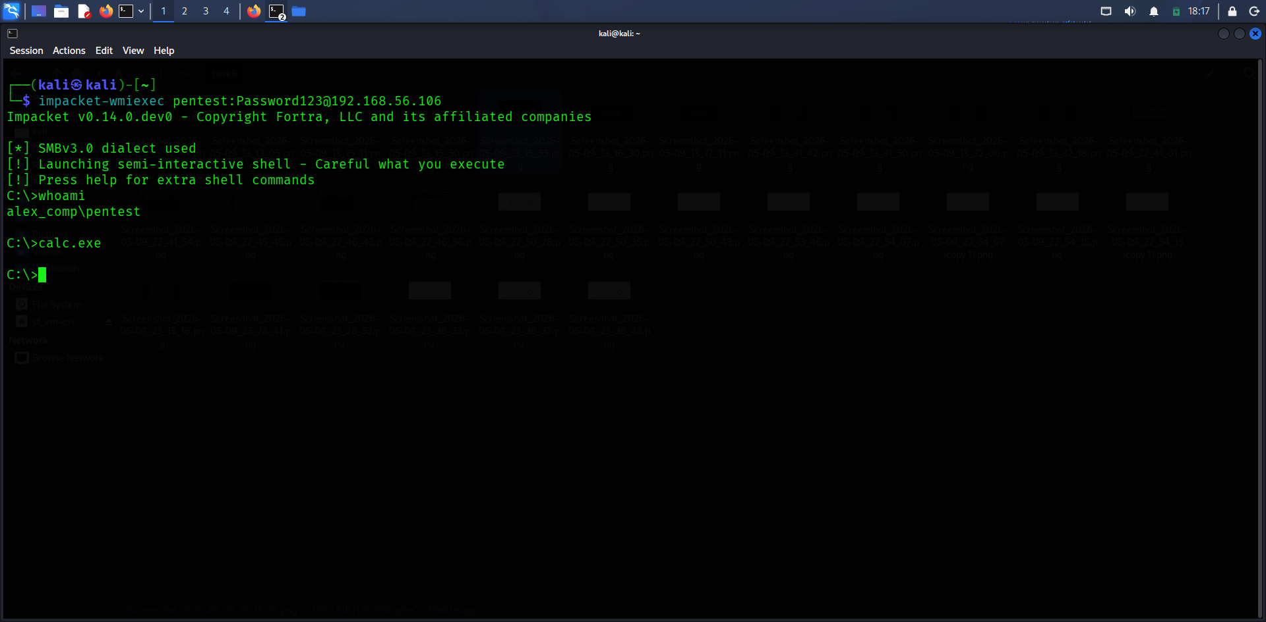

Additional PowerShell interactions and credential-related operations were performed to establish persistence and execute malicious commands. The activity demonstrated how legitimate administrative tools can be abused for offensive operations.
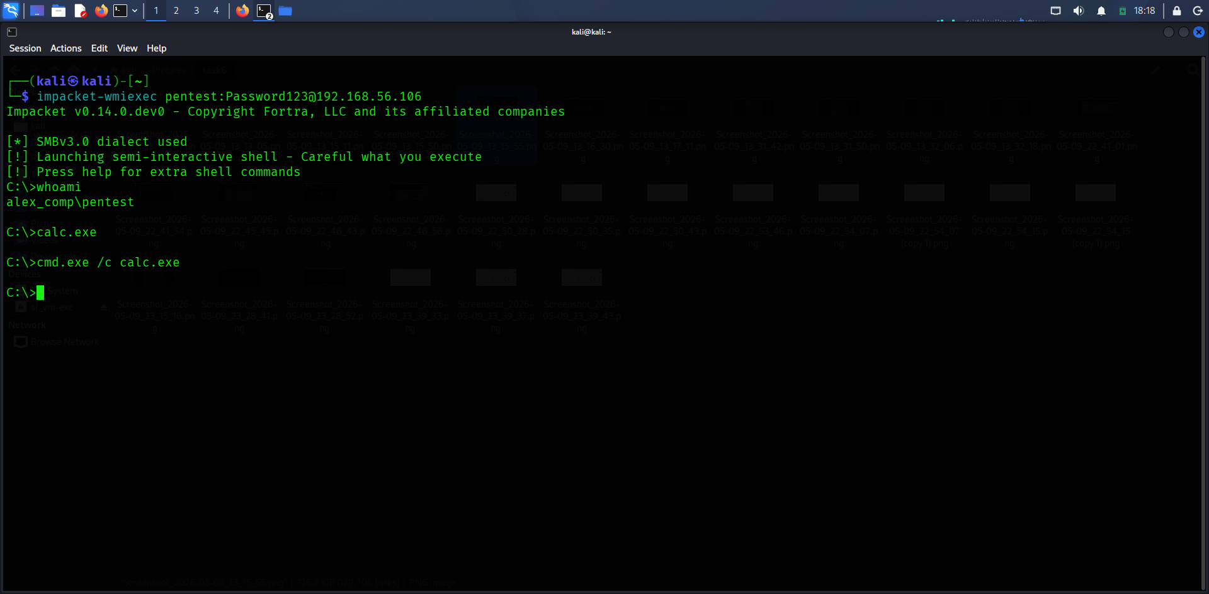

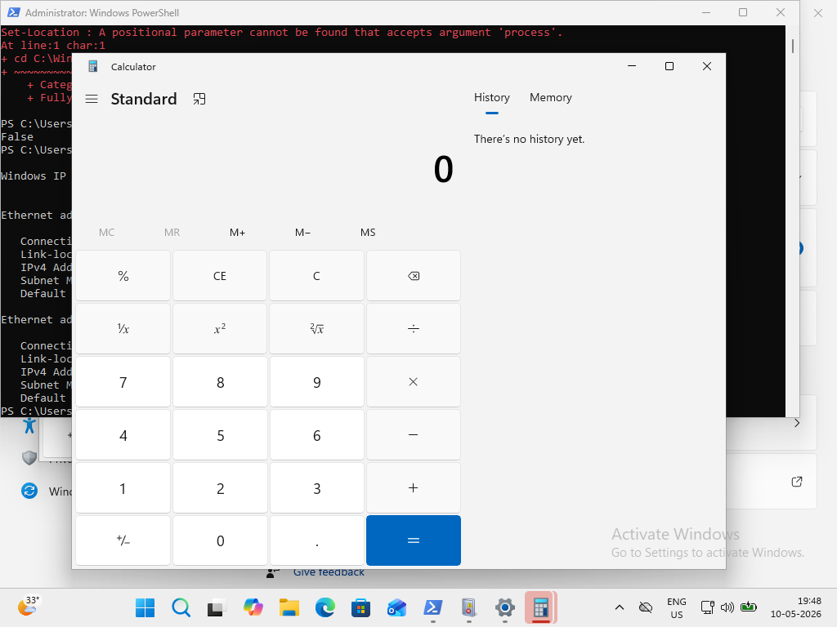

5. Monitoring and Detection Setup
Wazuh monitoring services were initialized to collect endpoint telemetry and security events. The platform successfully detected suspicious PowerShell execution patterns and system activities generated during the attack simulation.
The Wazuh dashboard was used to validate endpoint registration and monitor generated alerts in real time. This provided visibility into the execution of Living-Off-the-Land techniques.
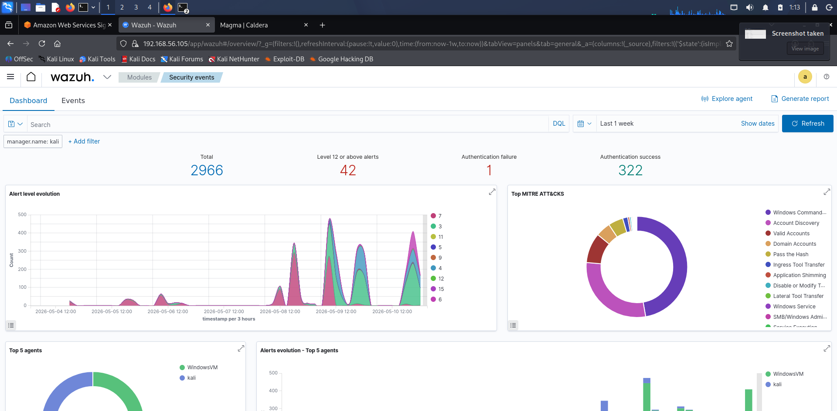

6. Security Event Analysis
During the attack execution, Wazuh generated multiple alerts associated with suspicious PowerShell activity, credential-related operations, and endpoint monitoring events. The alerts confirmed that the monitoring environment successfully detected activities commonly associated with adversarial behavior.

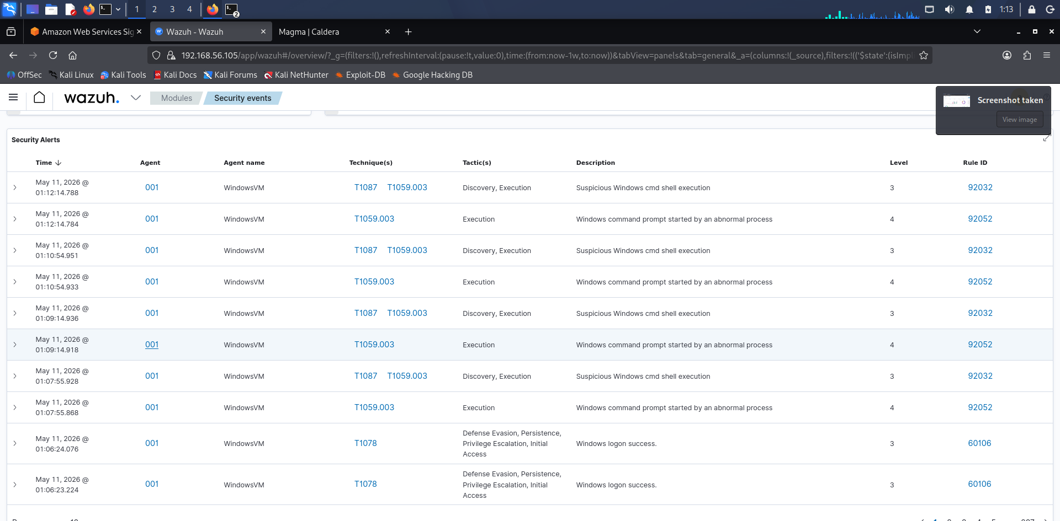

Detailed inspection of the alerts provided insight into command execution, event correlation, and detection rules triggered by the simulated attack activities.

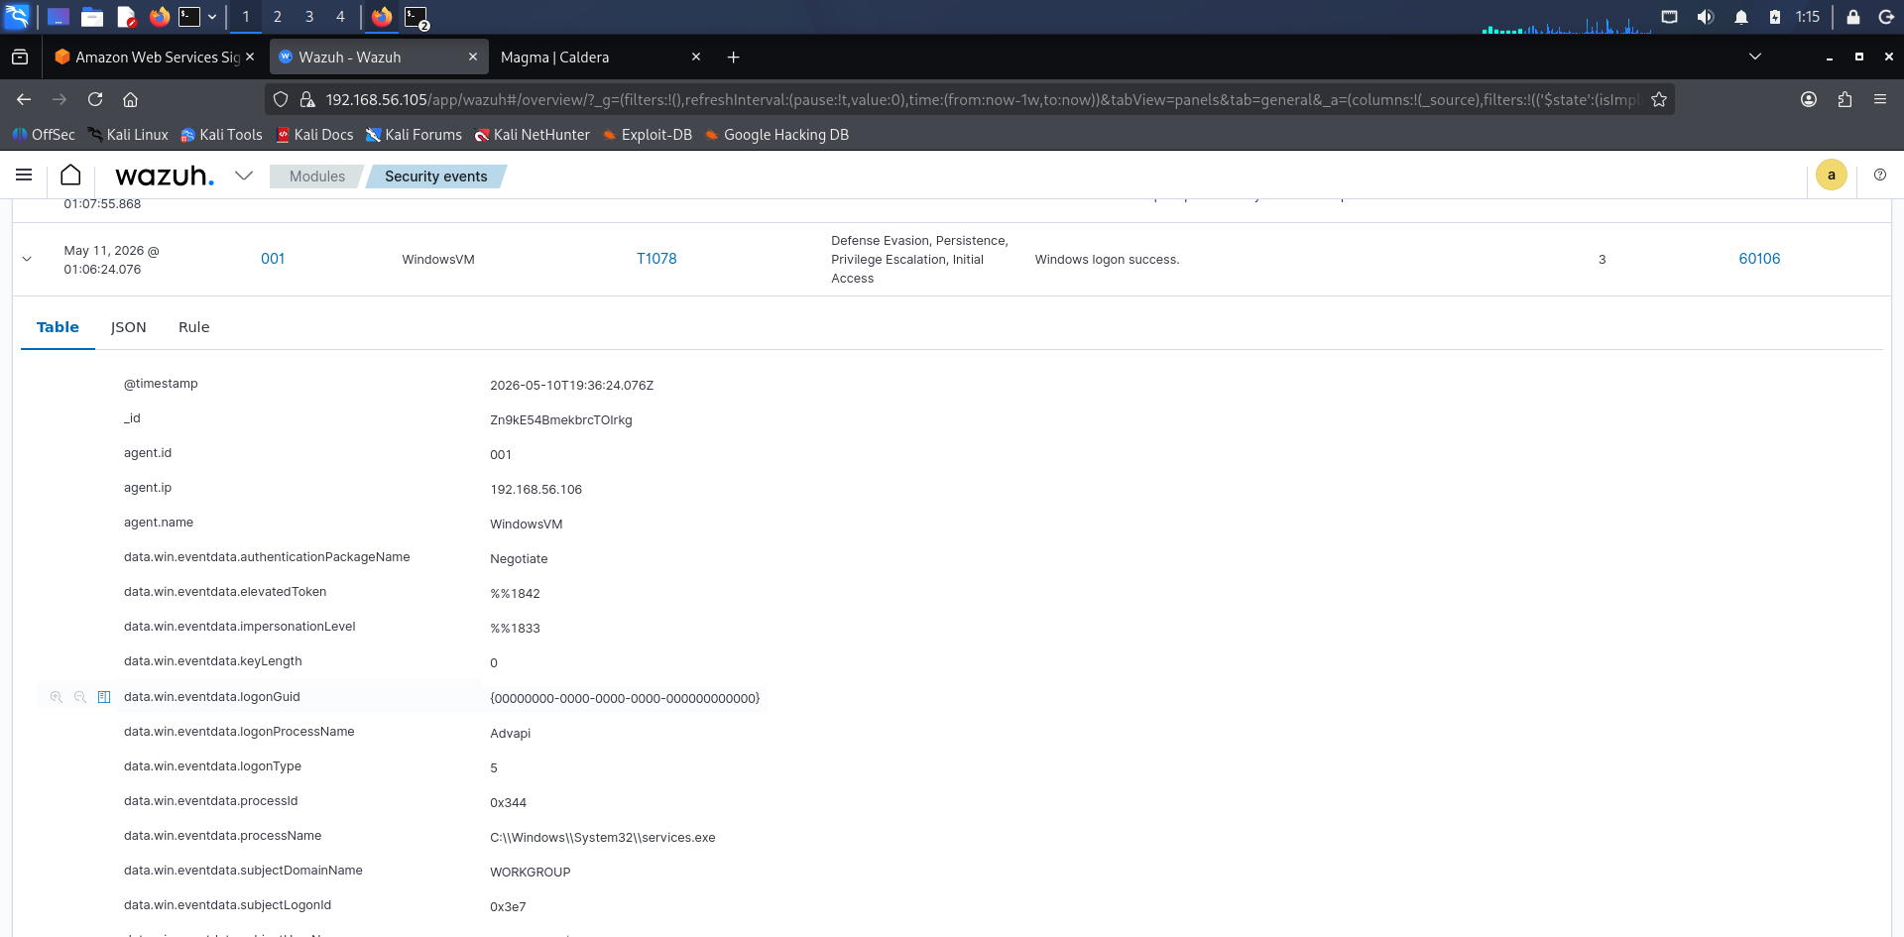

7. Attack Activity Log

Attack ID | Tool | Action | Notes
LID001 | PowerShell | Fileless execution | Bypassed traditional AV detection
LID002 | Mimikatz | Credential interaction | Simulated credential harvesting activity
LID003 | WMI | System interaction | Executed native administrative queries
LID004 | Wazuh | Alert monitoring | Detected suspicious endpoint activities

8. Credential Harvesting Summary
Credential harvesting activities were simulated using native Windows administrative tools and Mimikatz. PowerShell and WMI were leveraged to interact with the target environment while minimizing disk artifacts.

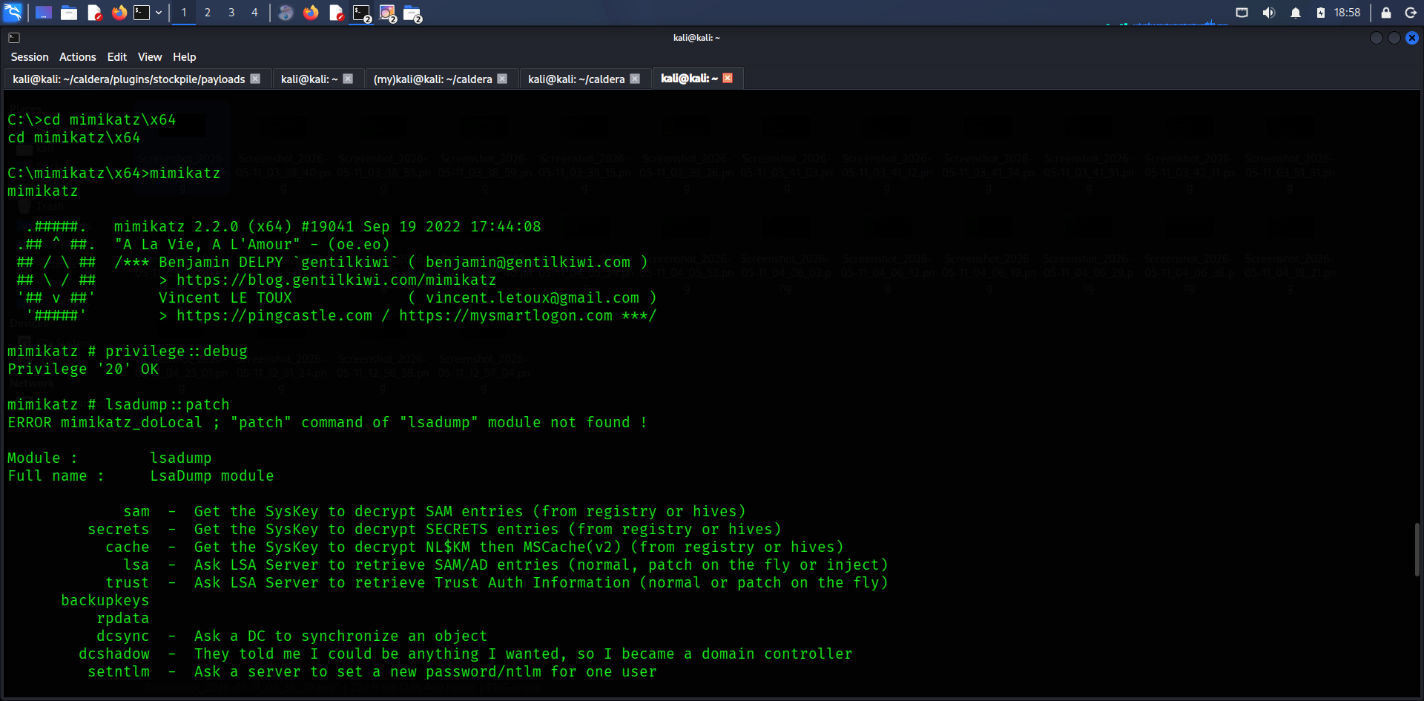

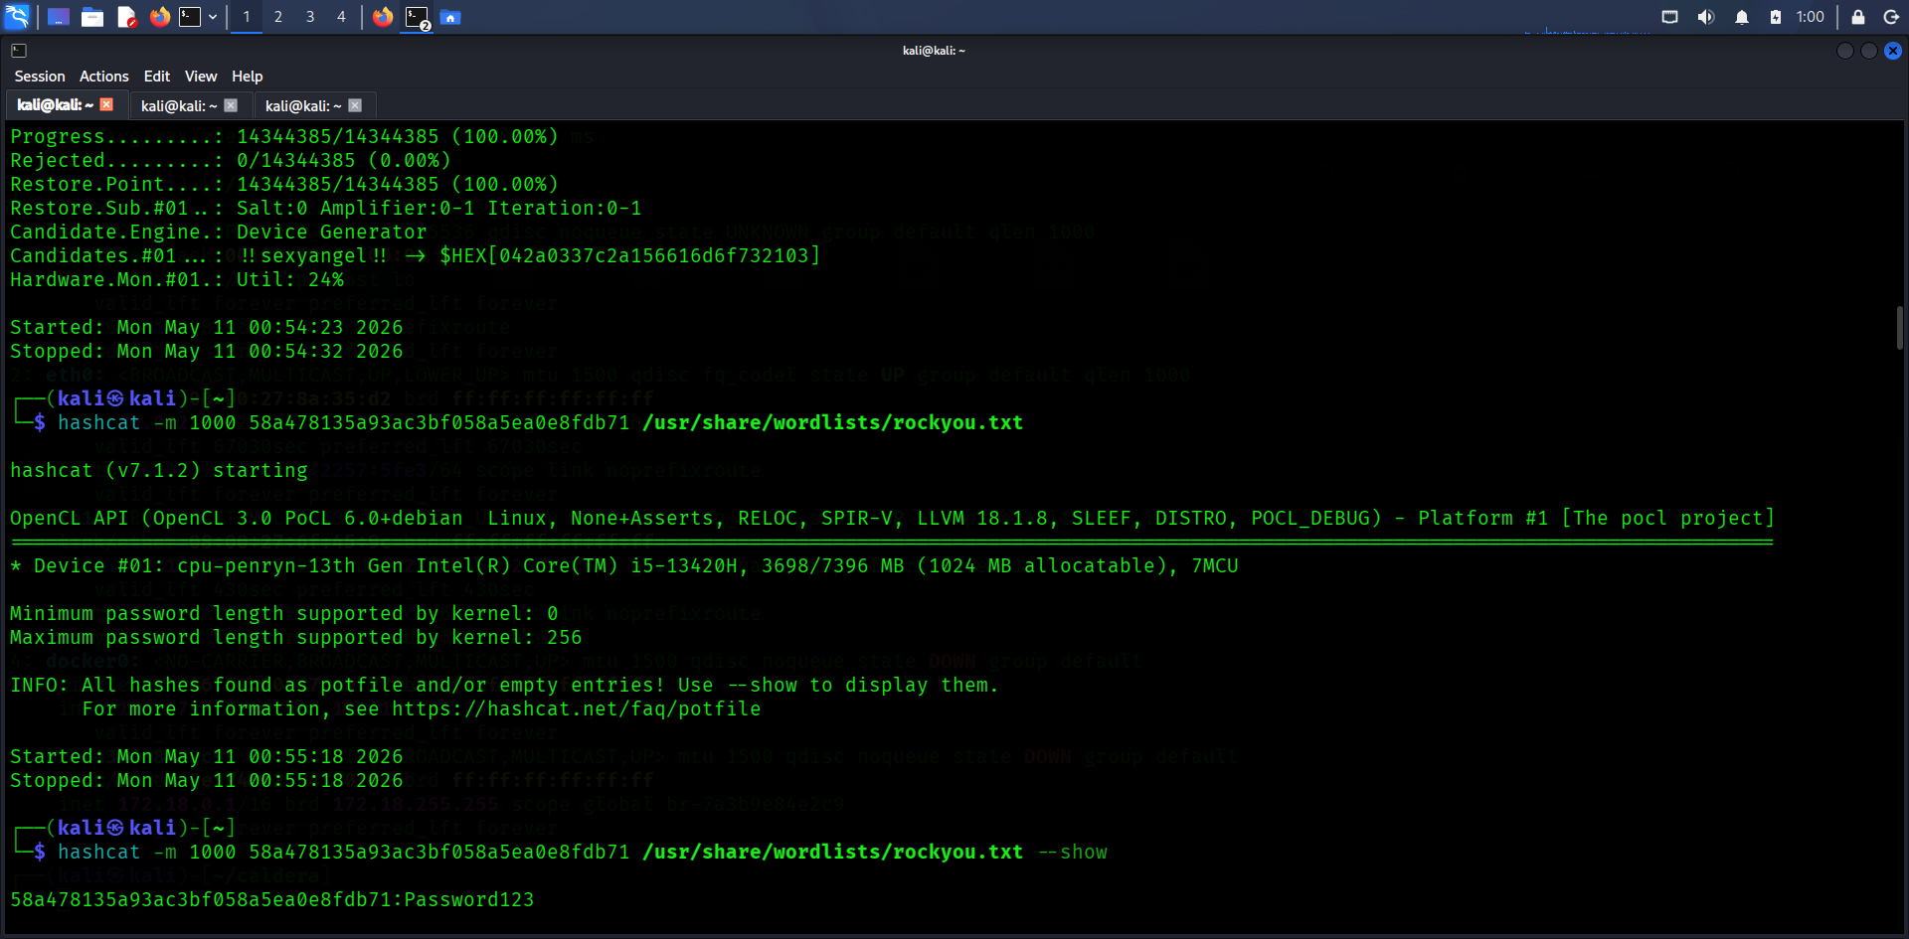
Wazuh monitoring successfully detected suspicious activities and generated alerts related to PowerShell execution and credential access attempts during the simulation.

9. Conclusion

The Living-Off-the-Land lab successfully demonstrated how legitimate Windows tools can be abused for offensive operations such as fileless execution and credential harvesting. The exercise highlighted the importance of behavioral monitoring and endpoint visibility in detecting advanced attack techniques. Wazuh effectively identified suspicious activity and provided valuable forensic insight into attacker behavior.

